

**User Manual**

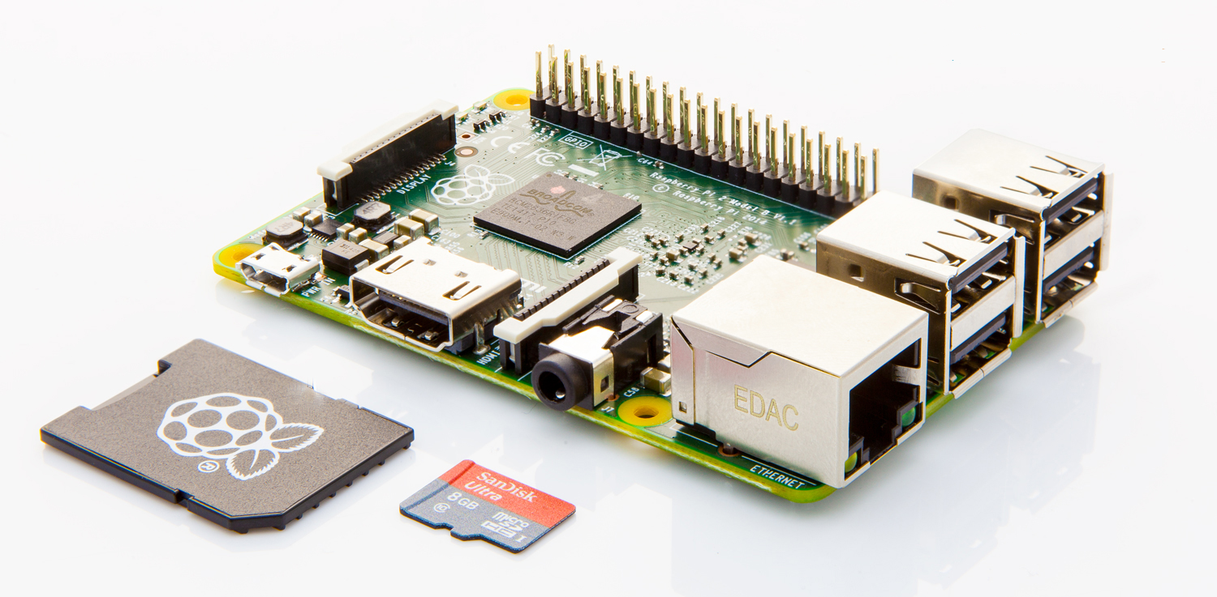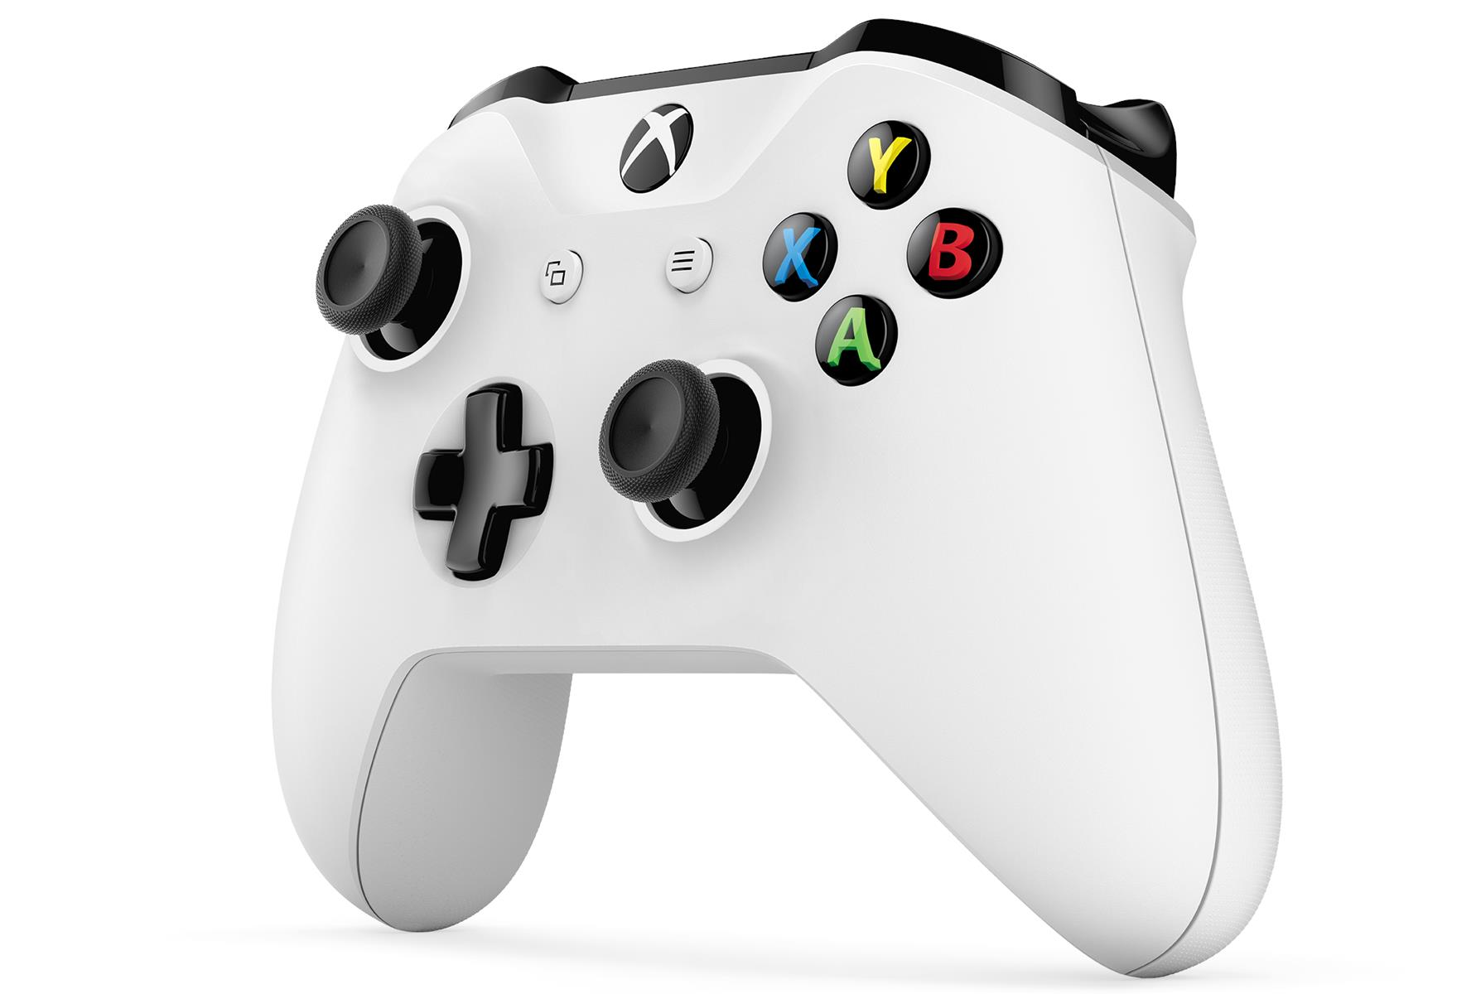

Raspberry Pi 2 Model B XBox One S Controller

Table of Contents

**About ozzTv2**

**ozzTv Installation3**

Requirement for local computer3

Preparing SD card3

Deploying solution4-5

**Home Screen 6**

**Input devices 7**

**Browser window 8**

**Music window 9-10**

**Photo window 11**

**File explorer window 12-13**

**Video window14-17**

**About ozzTv**

The ozzTV project is expected to create a system for an embedded computer, which will turn it into a smart TV or set up box; with just a few modifications to the hardware structures. The set up box will be hosting a Raspberry Pi to be used as the embedded computer. It will be perfect for its purpose, based upon its specifications. At the end of the project, the user shall be able to use their old or classic TV as if it was a brand new smart TV.

1. **ozzTv Installation**
   1. **Requirement for local computer to cross compile solution**

* Local computer running Windows 10
* Visual Studio Enterprise 2015 with Update 3
* Windows 10 IoT core Dashboard
* Active internet connection
* RJ-45 Ethernet port and Ethernet cable
  1. **Preparing SD card**
* Remove SD card from Raspberry Pi 2 and format it on the local computer
* Open Windows 10 IoT core Dashboard (ensure there’s an internet connection)
* Select the specific letter of the SD card for the IoT core to be installed (be careful not to select the wrong drive)
* Allow the application to download the required files from Microsoft’s server and prepare SD card
* Remove SD card from local computer and insert into Raspberry Pi 2 (ensure there’s no power to the board)

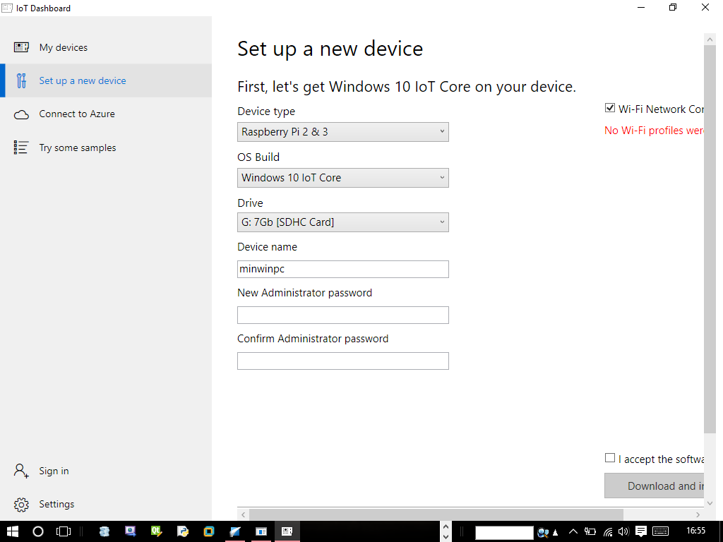

Select drive letter

Read EULA, before continuing. If EULA suites you, accept the agreement and click download and install button

Enter a device name and password now for administrative privileges or change it after installation

* 1. **Deploying solution**
* Make connection between the Raspberry Pi and the display unit via a HDMI cable
* Make connection between the Raspberry Pi and the local computer via a RJ-45 cable
* Connect the power supply to the Raspberry Pi board
* Go back to IoT core dashboard to ensure your board is detected
* Unzip the solution provided on the optical disc
* Open the ‘ozzTv’ solution via Visual Studio 2015
* Select Debug from the menu bar of visual studio
* Select Deploy ozzTv
* Select your Raspberry Pi 2 board as the remote machine
* Sit back and wait for deployment to complete
* If there are any security authentication enabled on the board, wait for the deployment bridge to require you to enter the pin or password
* Use ozzTv

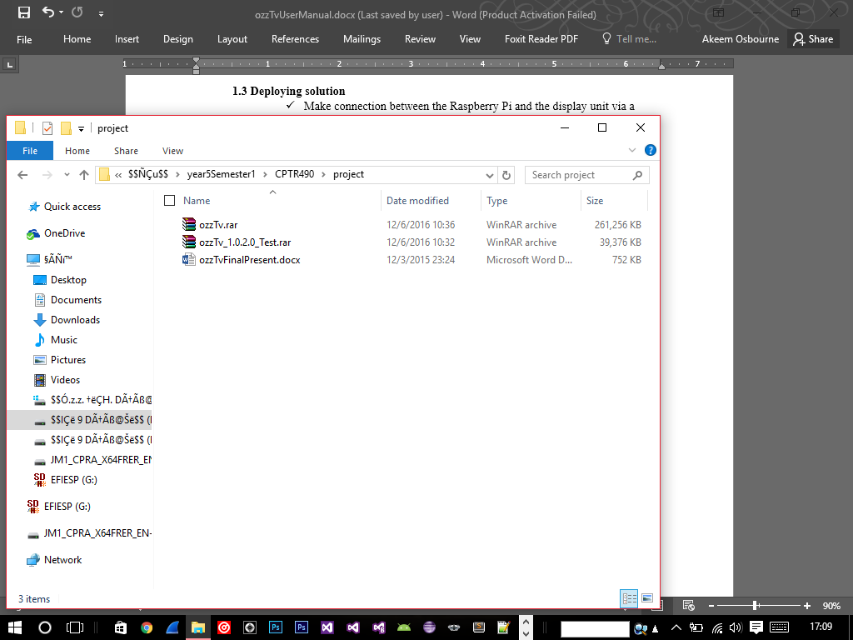

Unzip ozzTv.rar

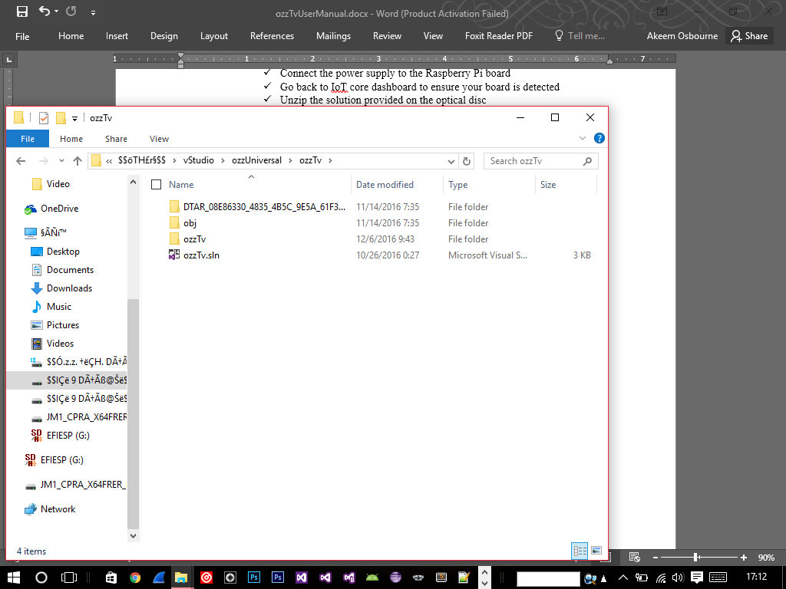

Double click ‘ozzTv.sln’ to open the solution

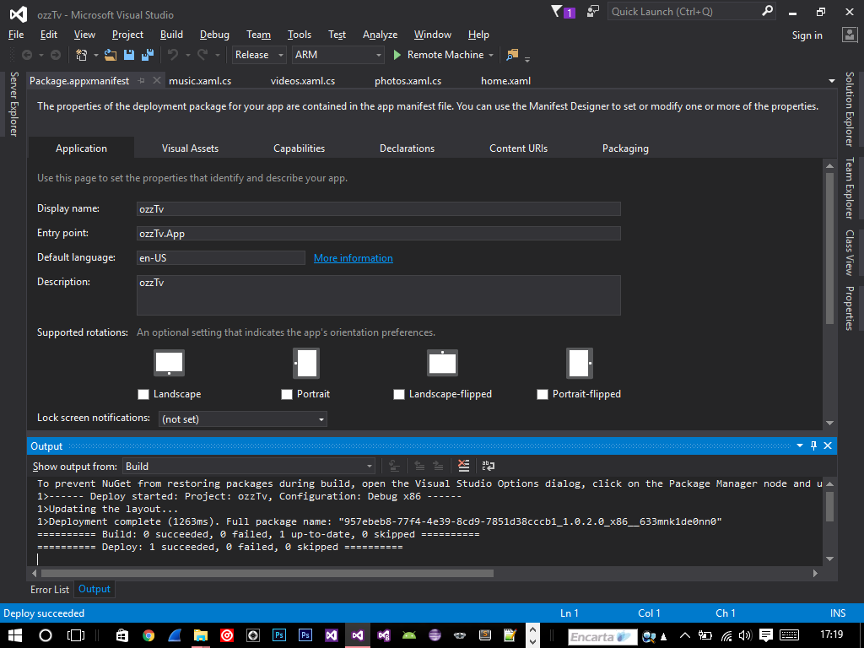

Ensure your configuration settings resembles the ones above

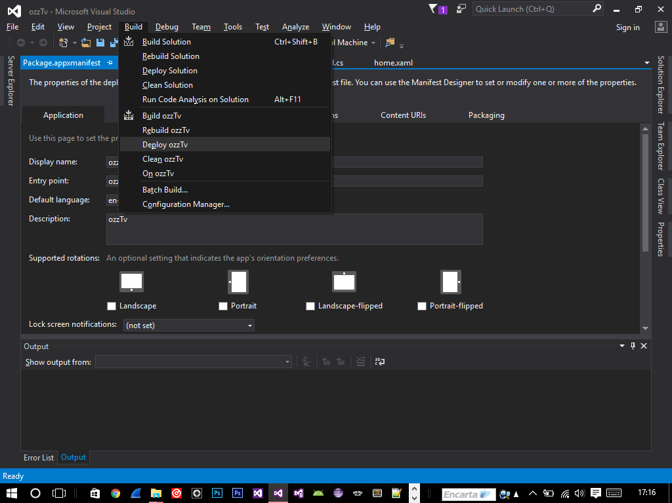

After the IDE loads, click the build menu and click ‘Deploy ozzTv’ deployment will take a few minutes. After successful deployment, the system will be loaded automatically, enjoy.

1. **Home Screen**

The home screen of the system contains basic navigations. The system is intuitively easy to use and will be adapted after few clicks.

Current time

Calendar of the system

Browser grid of the system

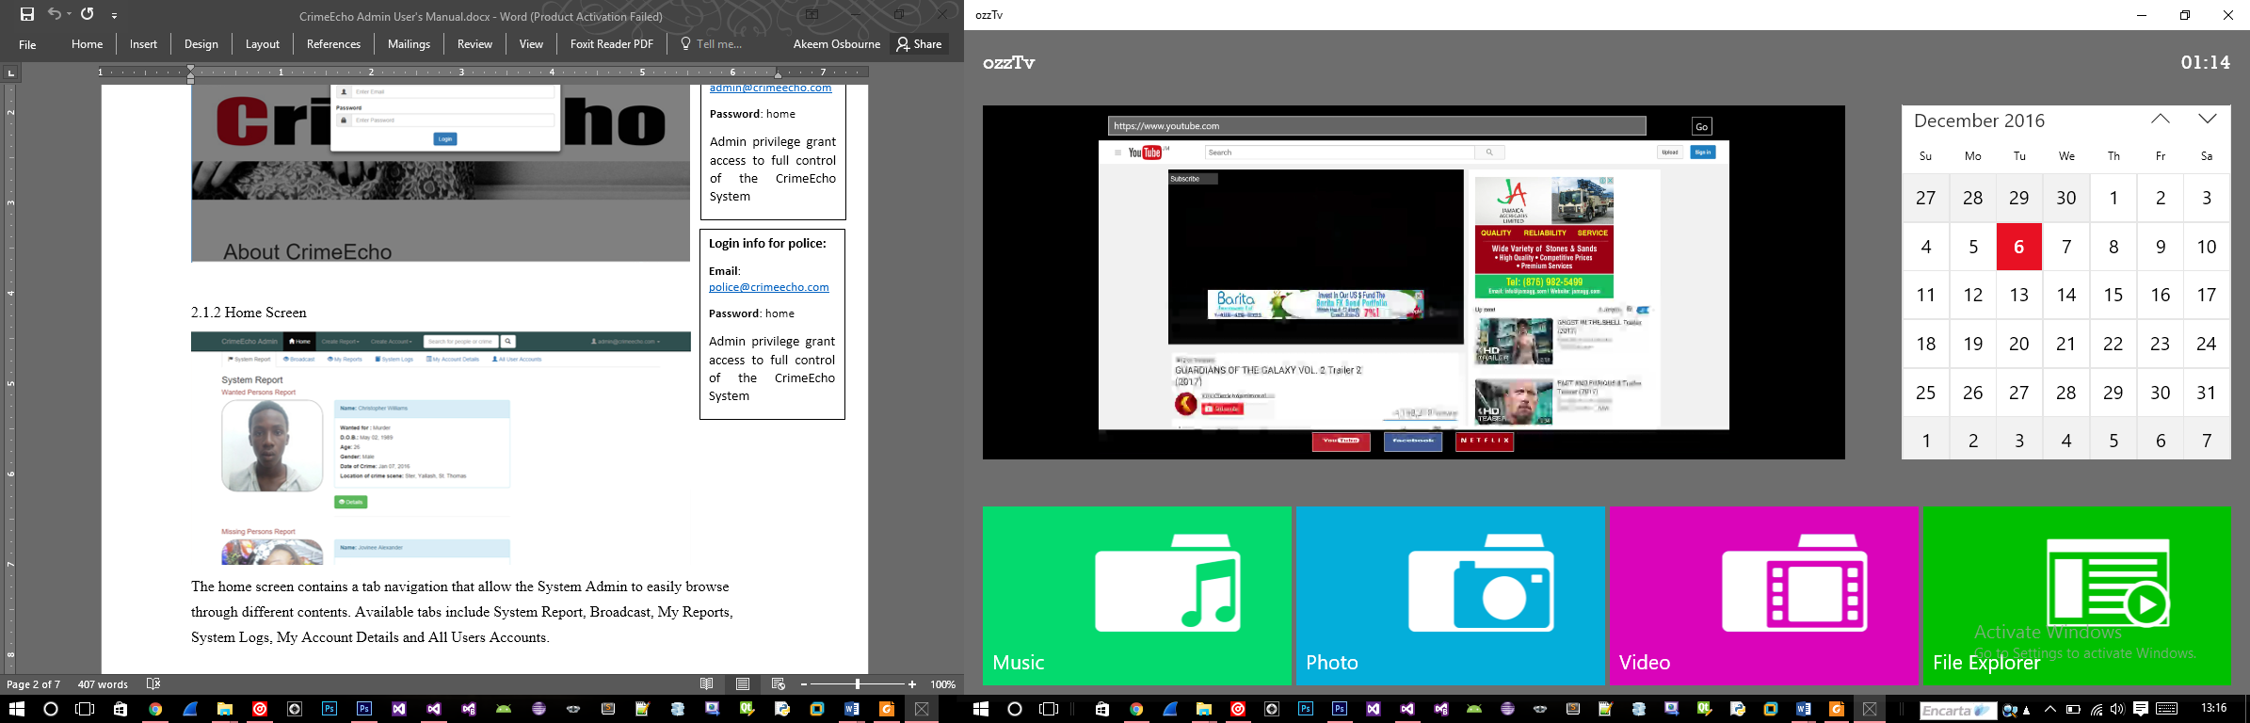

Music grid

Photo grid

Video grid

File explorer grid

1. **Input devices**
   1. Xbox one controller (Recommended)

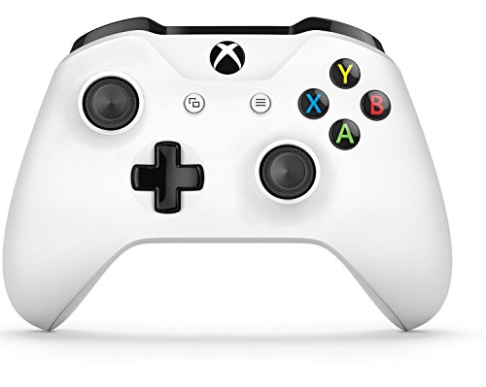

Back

Select

Navigation

* 1. Wireless mouse

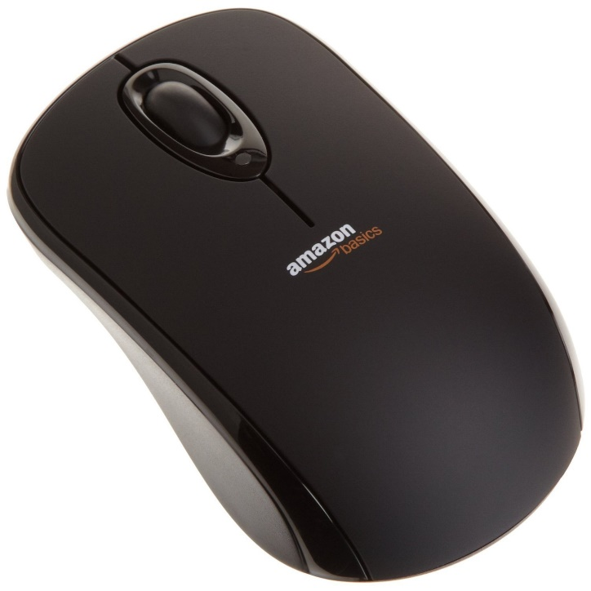

Select

1. **Browser window**

Upon clicking the browser window from the home screen, the browser will be loaded as depicted on the image below.

Go to url

Web address

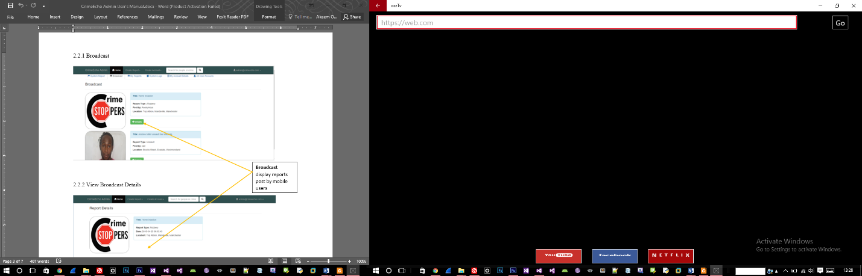

Favorite link: Netflix

Favorite link: Facebook

Favorite link: Youtube

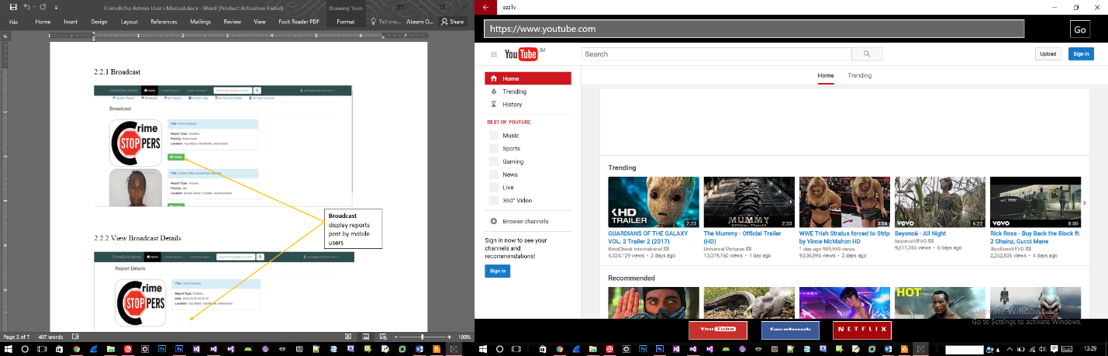After entering a web address, or clicking a favorite link, the browser window will be updated, but at a scaled level.

1. **Music window**

All media from this window will be added automatically after the system scans the removable device(s) for audio files within a specific extension range (.mp3, .wma, etc).

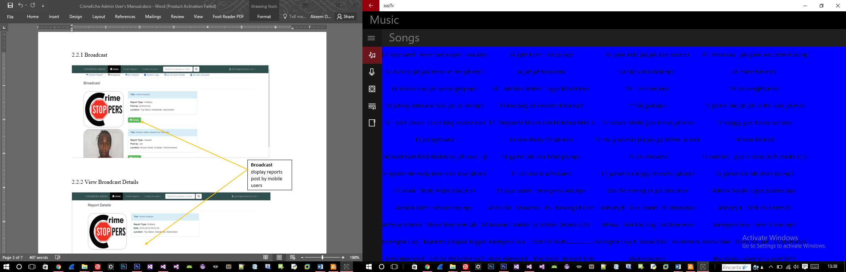

Song from the user media drive

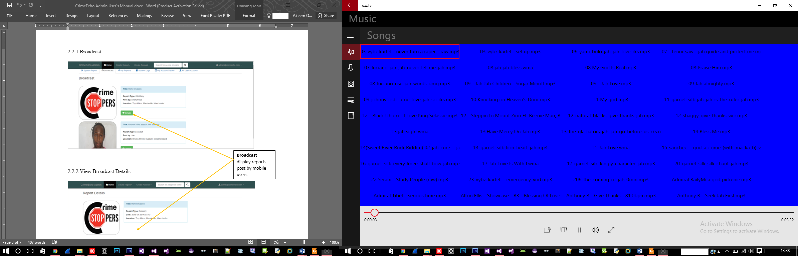

Media player

**N.B. Since your new device was designed to run on Microsoft IoT, you have the capabilities of casting your media to other devices in your home.**

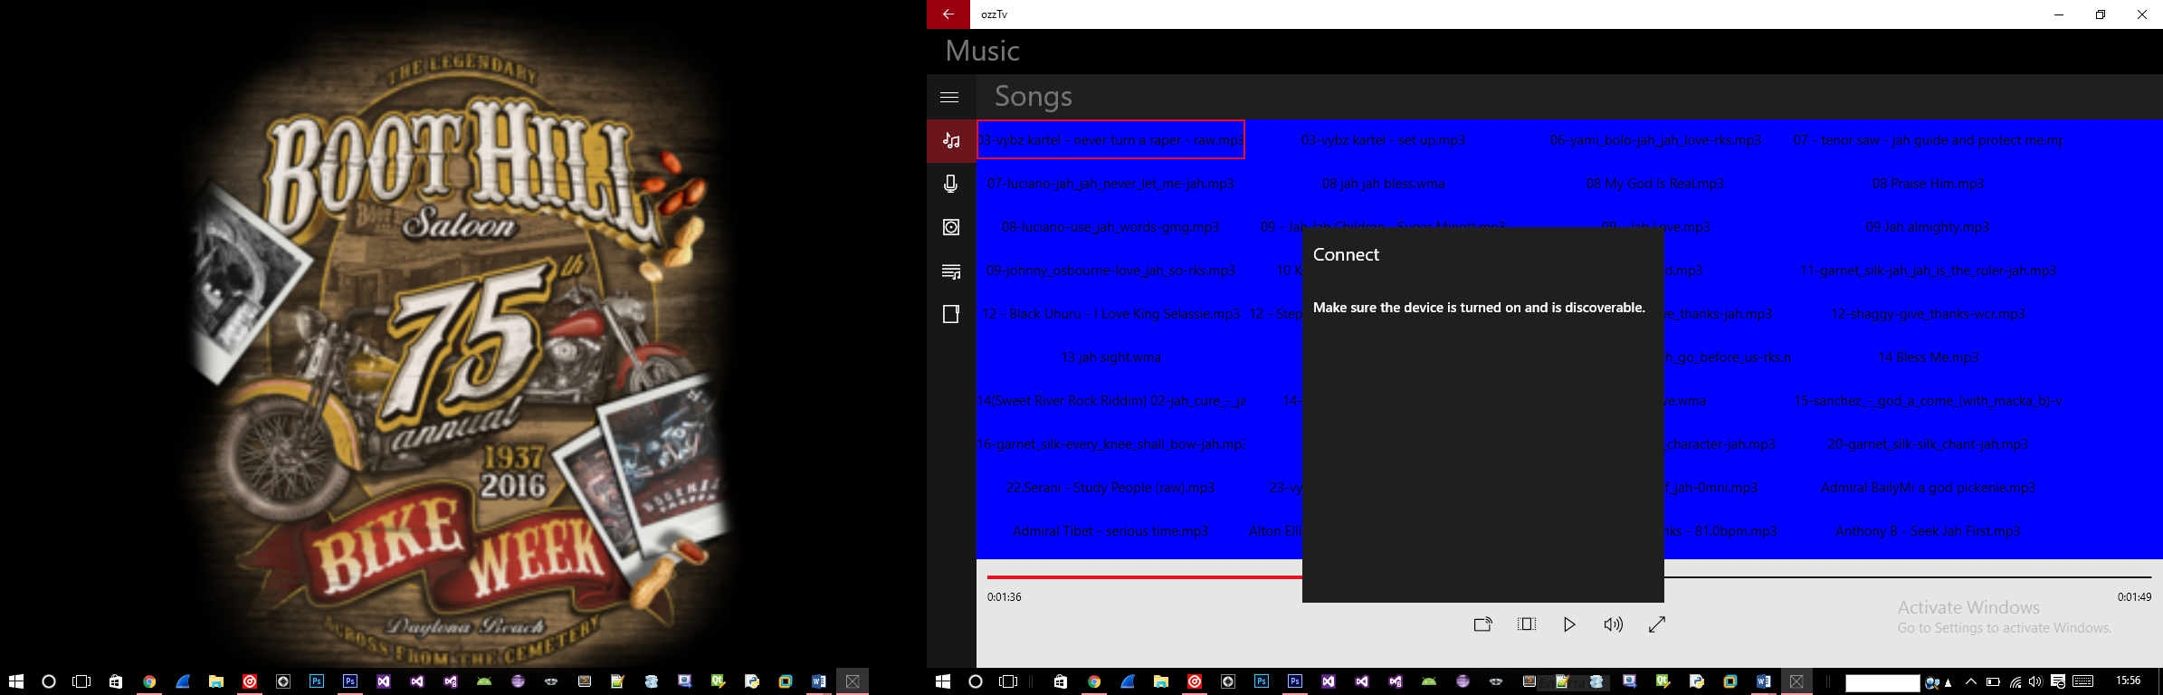

Full screen

Volume adjuster

Aspect ratio

Cast

Play/Pause

1. **Photo window**

All media from this window will be added automatically after the system scans the removable device(s) for photo files within a specific extension range (.jpg, .jpeg, etc).

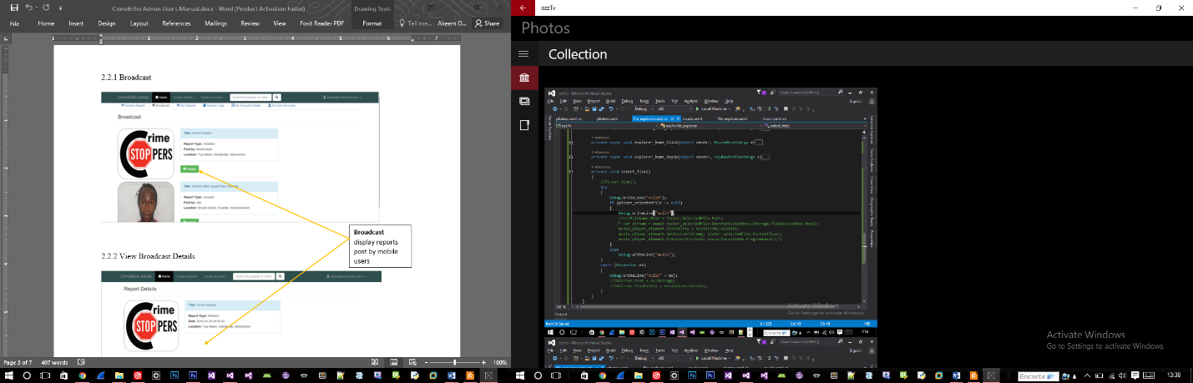

Photo from user media drive

1. **File explorer window**

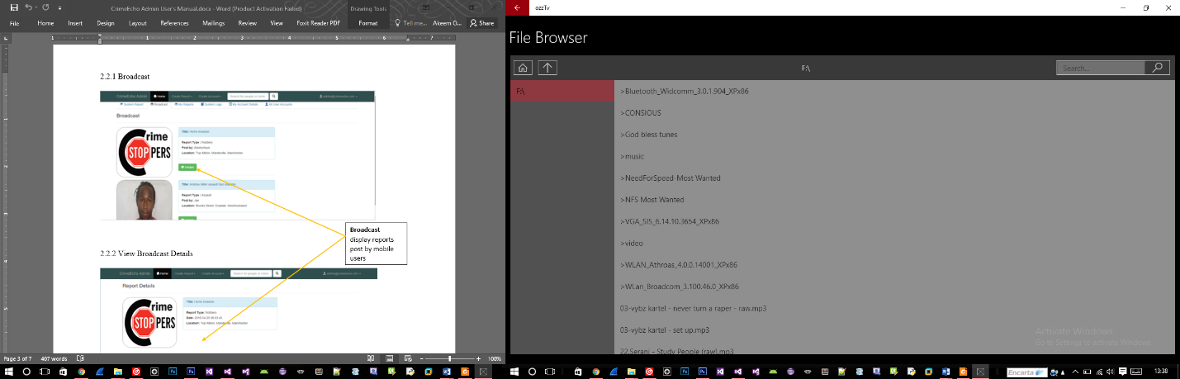

Folder up

Removable drive

Files and folders

Folder address

Drive home

Navigating within the file explorer is similar to any native file explorer. To browse a removable device, do the following:

1. Insert a removable device
2. Select the device from the list of removable drive as depicted above
3. Browse to the designated file or folder
4. To go up a folder level, click the folder up icon

**N.B. The system will only display supported files within the file explorer.**

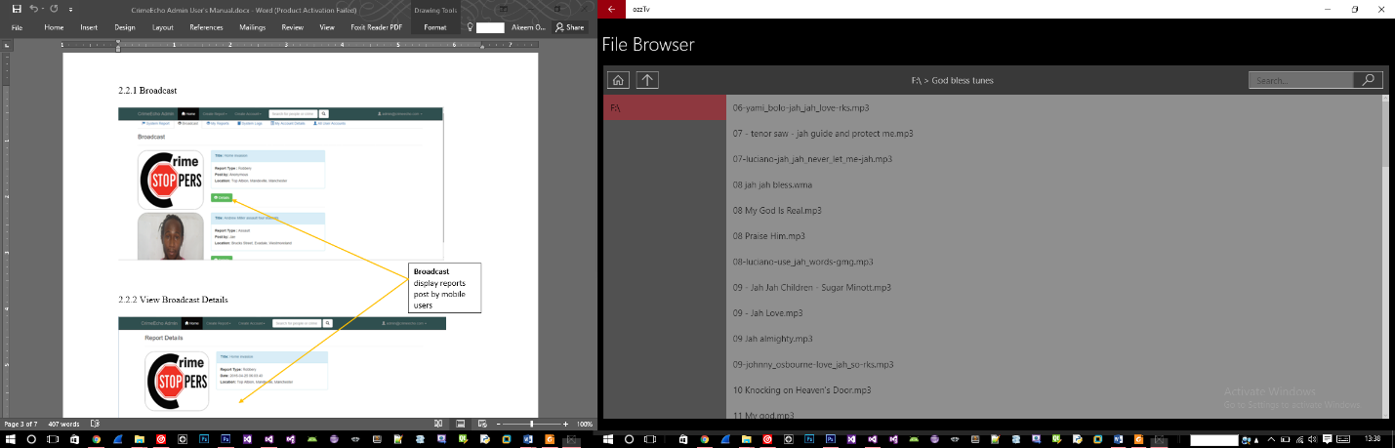

Folder address

1. **Video window**

All media from this window will be added automatically after the system scans the removable device(s) for video files within a specific extension range (.mp4, .avi, etc).

Video from media drive

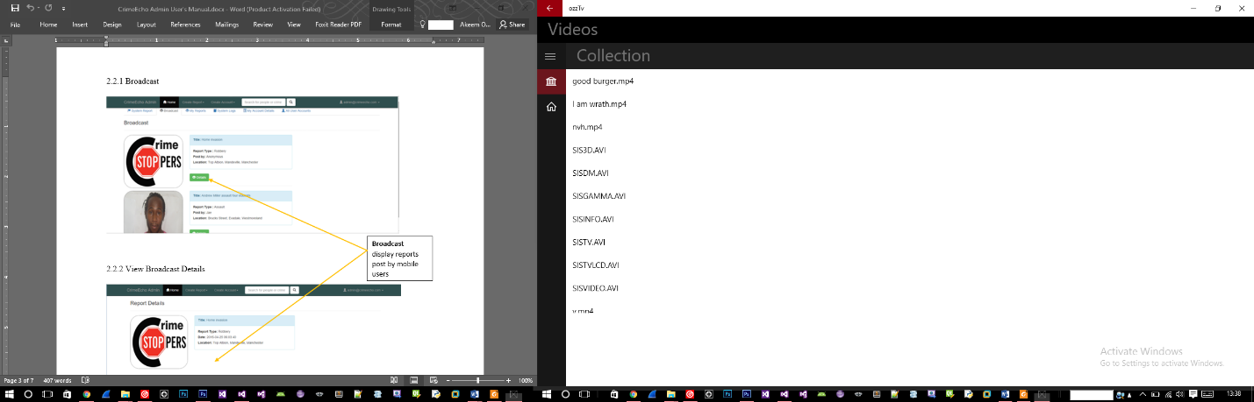

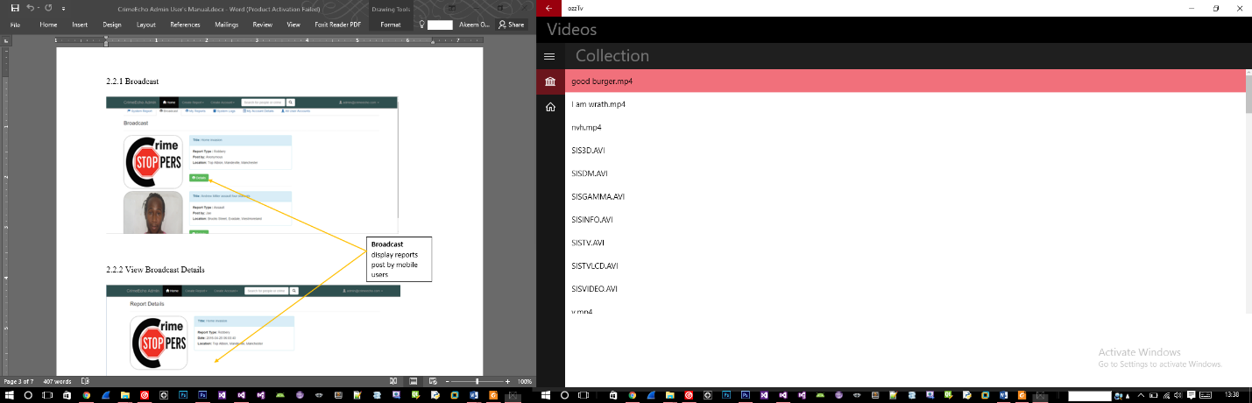

Selected video

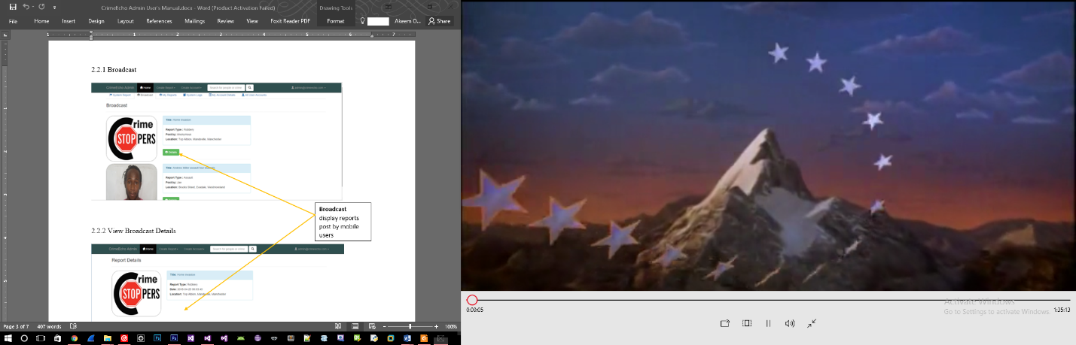

Media player

Video output

**N.B. After toggling between the fullscreen icon, the media player will window will be minimized as shown below.**

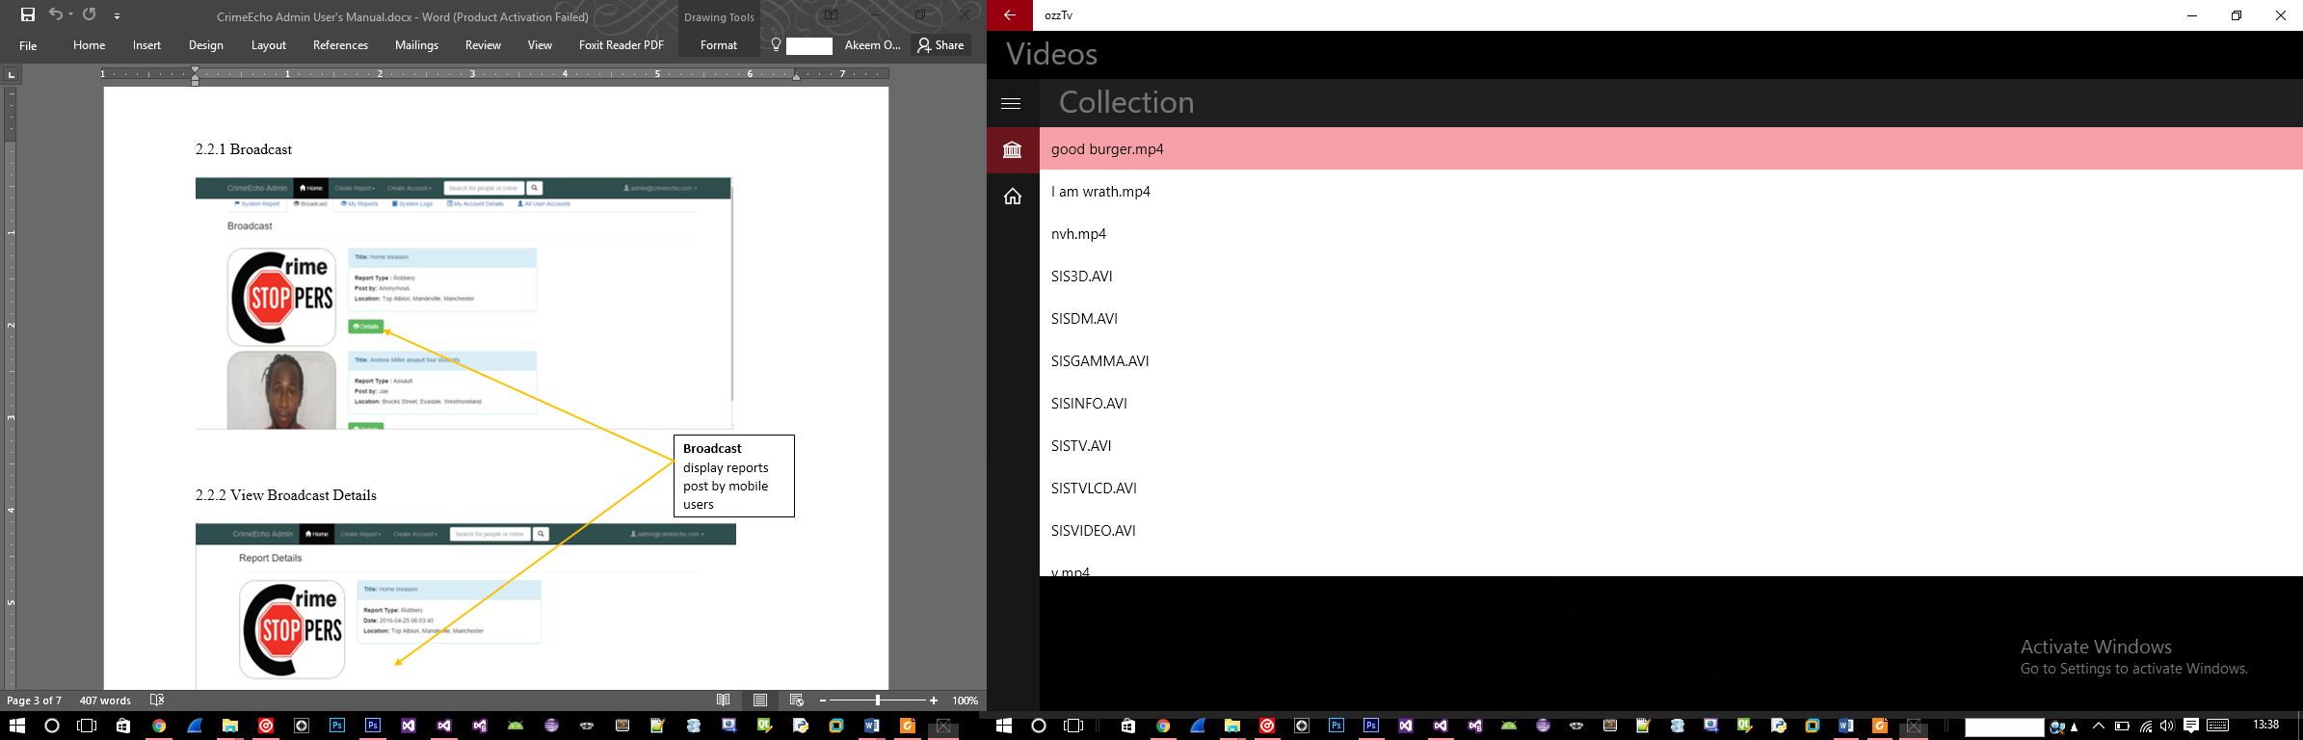

Minimized media player

Selected video